SRR & CVR Government Degree College (A) :: Vijayawada
Department of Computer Science
Report
on
One day Interdisciplinary National Webinar on
“Handling Machine Learning Projects - A Step Towards Data Science Career”
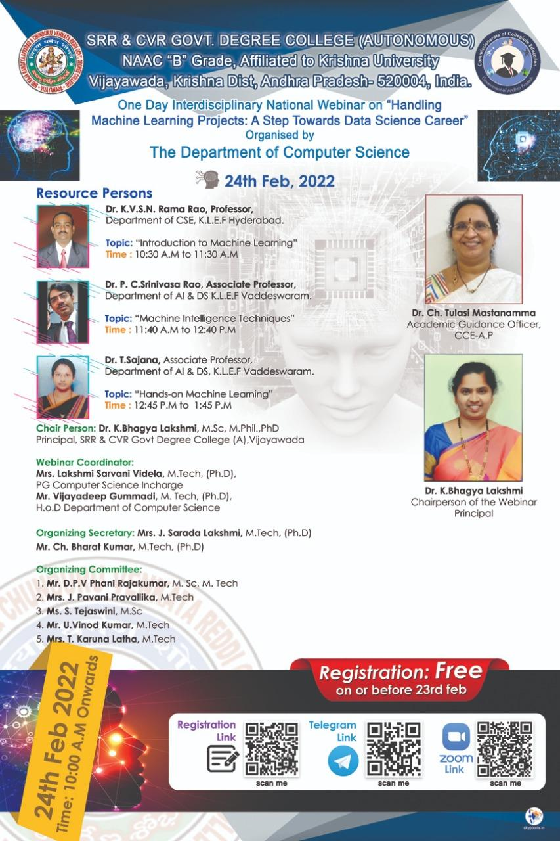
Date of the Workshop : 24-02-2022
Duration: 10: 30 A.M. to 1:45 P.M.
Objective: The purpose of this webinar was to educate students about machine learning projects and careers.
Learning Outcomes: The students will be able to learn
1. Fundamental machine learning principles.
2. Projects involving machine learning
3. Hands-on training in the implementation of a machine learning project using Google Colab
4. Optimization techniques to improve the performance of machine learning projects
Target Students: Anyone who wants to upgrade their knowledge and skills on machine learning.
Report:
A total of 653 participants registered for the webinar from all over India. 406 participants attended the webinar. Out of This interdisciplinary national webinar was conducted from 10: 30 A.M. to 1:45 P.M. on 24/02/2022. The event was coordinated by the entire Computer Science UG and PG faculty. The webinar had a diverse group of attendees. Students, Lecturers, Assistant professors, Associate professors, Professors, Research Scholars, Graduated students, Managers and Principals participated in the webinar.
Resource Person(s):
1. First Talk - Dr. K. V. S. N. Rama Rao, Professor,
Department of CSE ,
KL Hyderabad
Topic: Introduction to Machine Learning
2. Second Talk - Dr. T. Sajana, Associate Professor,
Department of AI & DS,
KL University
Topic: Hands-On Machine Learning
3. Third Talk - Dr. P. C. Srinivasa Rao, Associate Professor,
Department of AI&DS,
KL University
Topic: Machine Learning Techniques
At the end of the day participants learnt various career opportunities in machine learning, varied projects in machine learning, optimization techniques in machine learning, and how to implement a machine learning project using Google Colab.
Participants:
Number of students participated in the webinar : 174
Number of SRR college Students participated in the webinar: 130
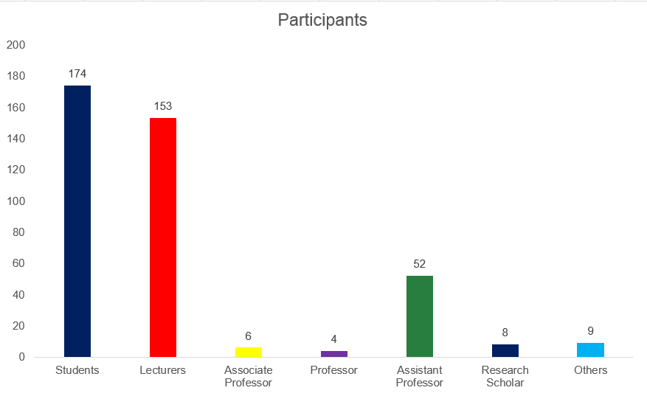

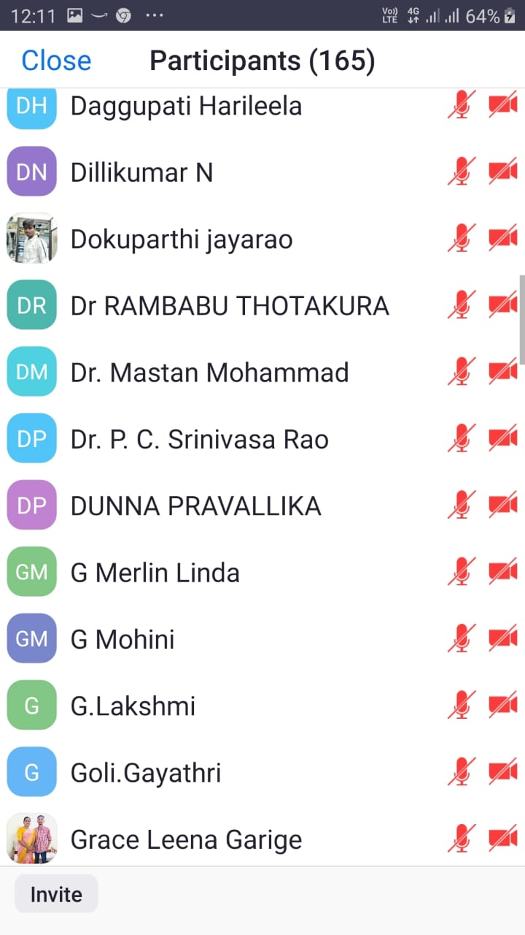

Screenshots:
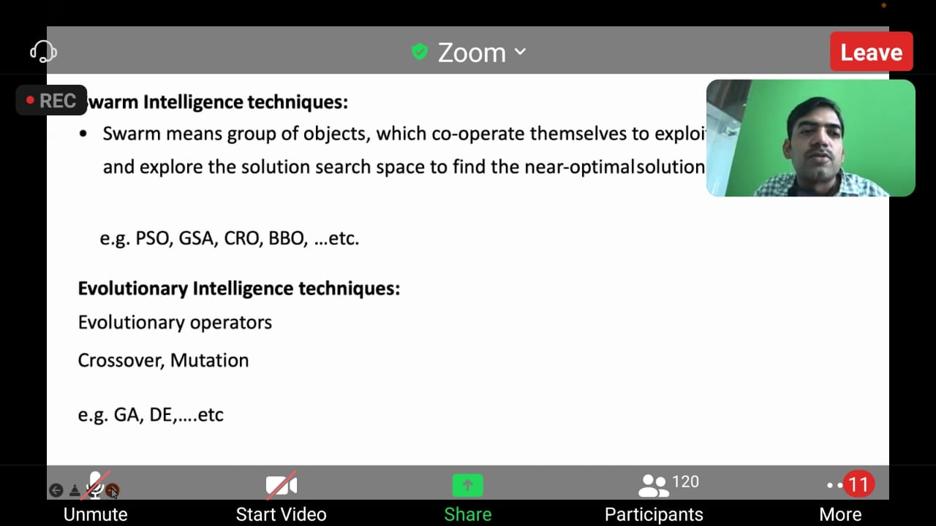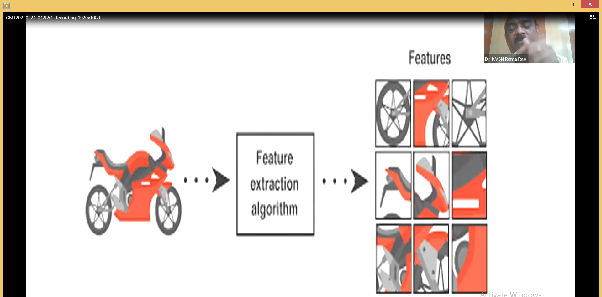
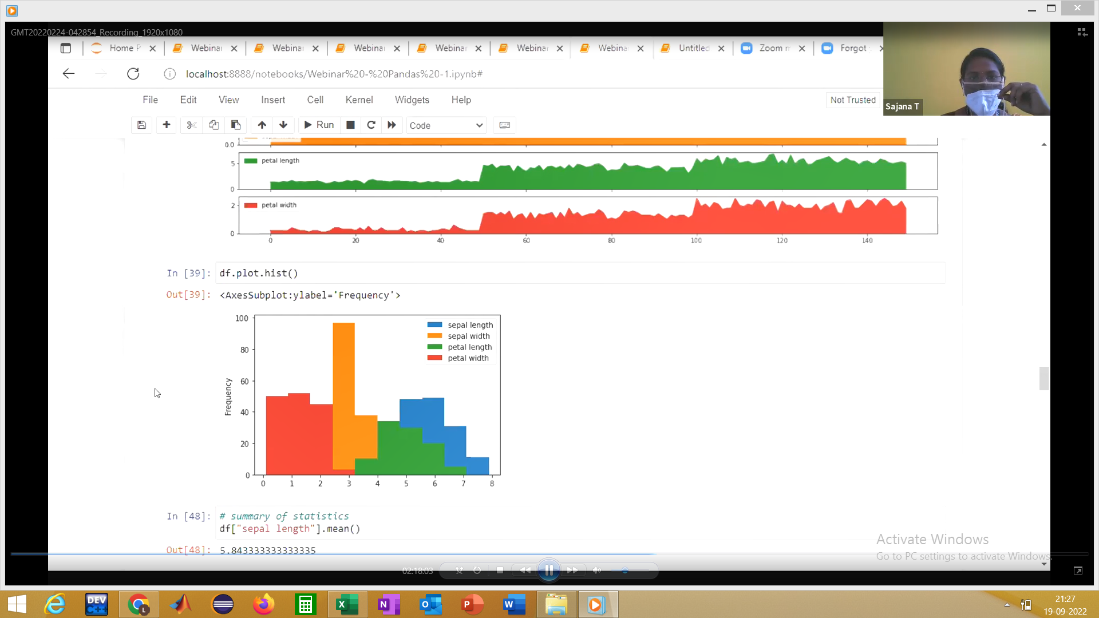
Faculty Coordinator(s):
- Mr. Vijayadeep Gummadi, Lecturer and In-Charge of Computer Science
- Ms. Lakshmi Sarvani Videla, PG Incharge of Computer Science
List of Participants Registered:
https://docs.google.com/spreadsheets/d/1I9ZCY8N1EmHWkFWlyFhqTsy49xl0rDNv/edit?usp=sharing&ouid=116351957315443523331&rtpof=true&sd=true

List of Participants gave Feedback and received Certificates:
https://docs.google.com/spreadsheets/d/1d92FcZLjFuRW-lCmzJJyFYUDPagaIHp4/edit?usp=sharing&ouid=116351957315443523331&rtpof=true&sd=true

Webinar Feedback: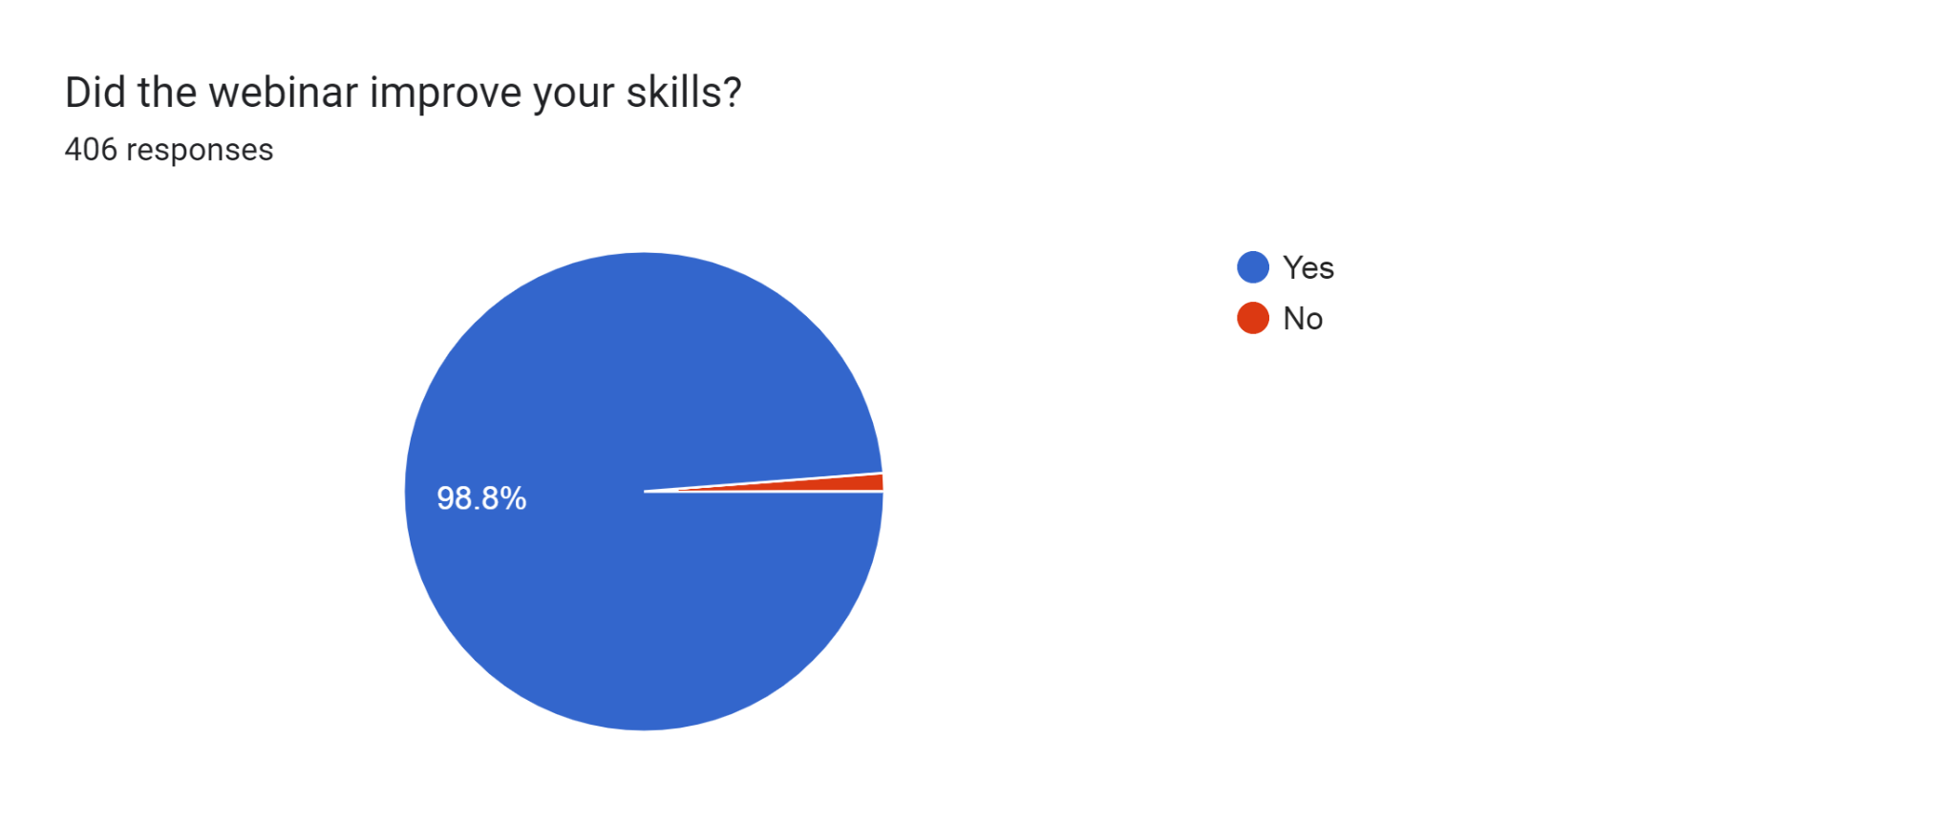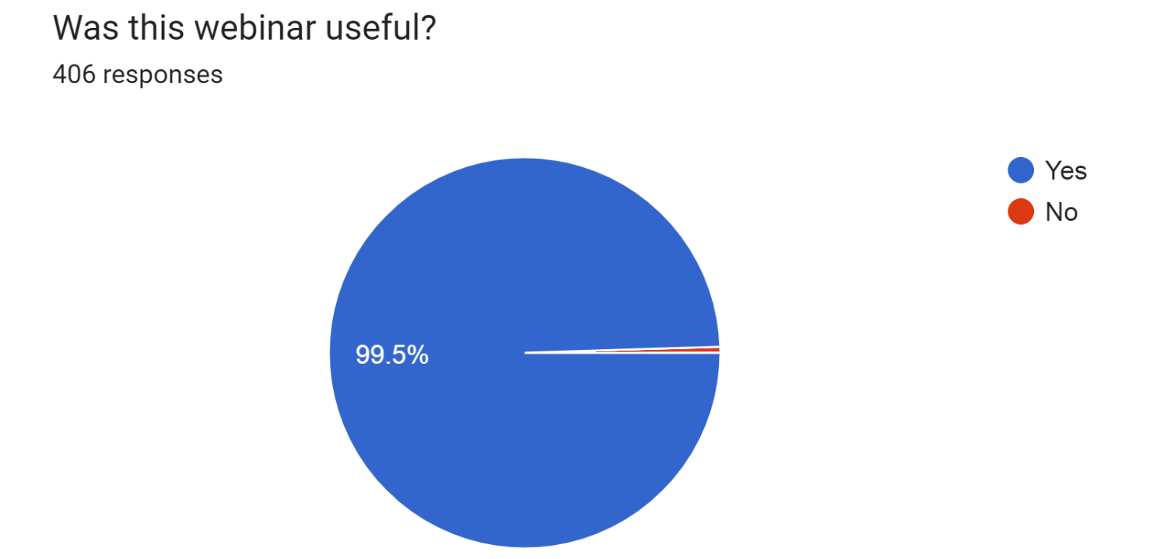

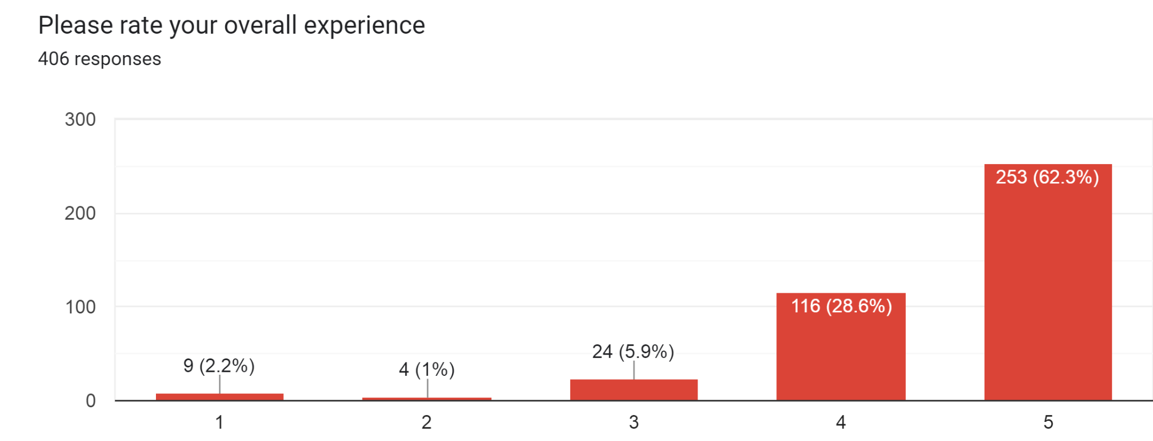
Sample Certificate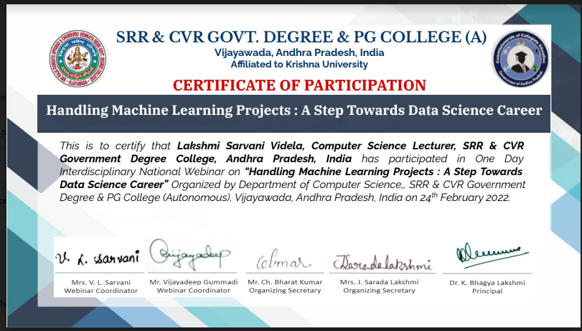

Webinar Successfully ended on 24/02/2022: